# *APLITUDE WEB APP (APLI Testing Under Direction and Evaluation Program):*

* It is an Assessment platform where, recruiter can give direction and evaluate candidate performance.
* Two types of users can use this app:

1. Recruiter/Admin => one user at a time.
2. Candidates => multiple users at a time.

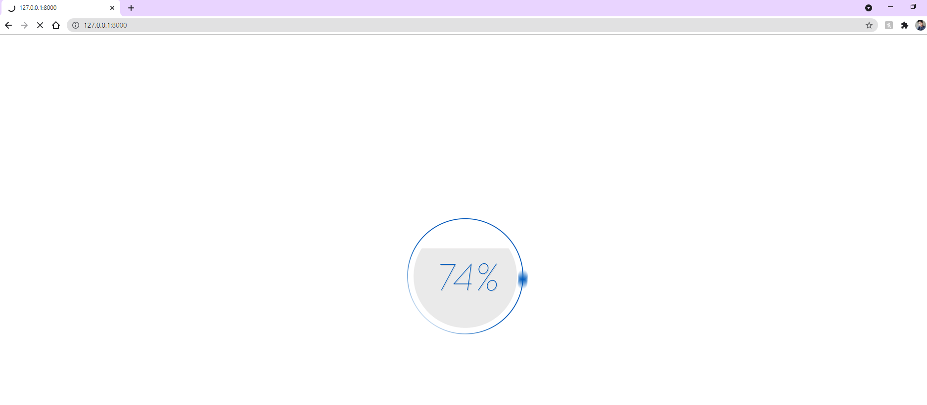

**Loader is showing while page is loading…**

# Home Page:

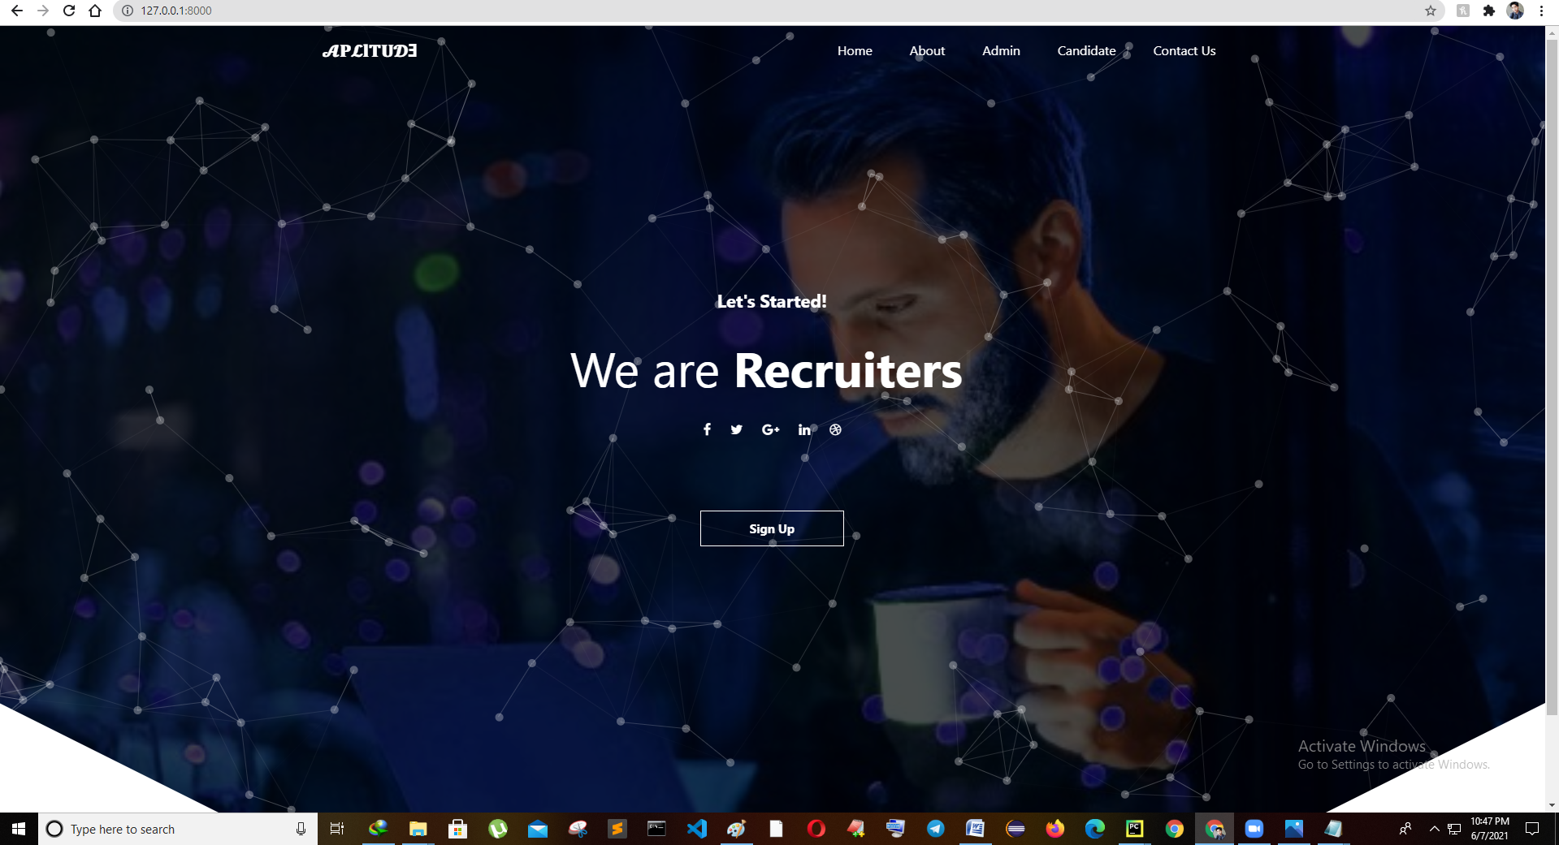

# About Page:

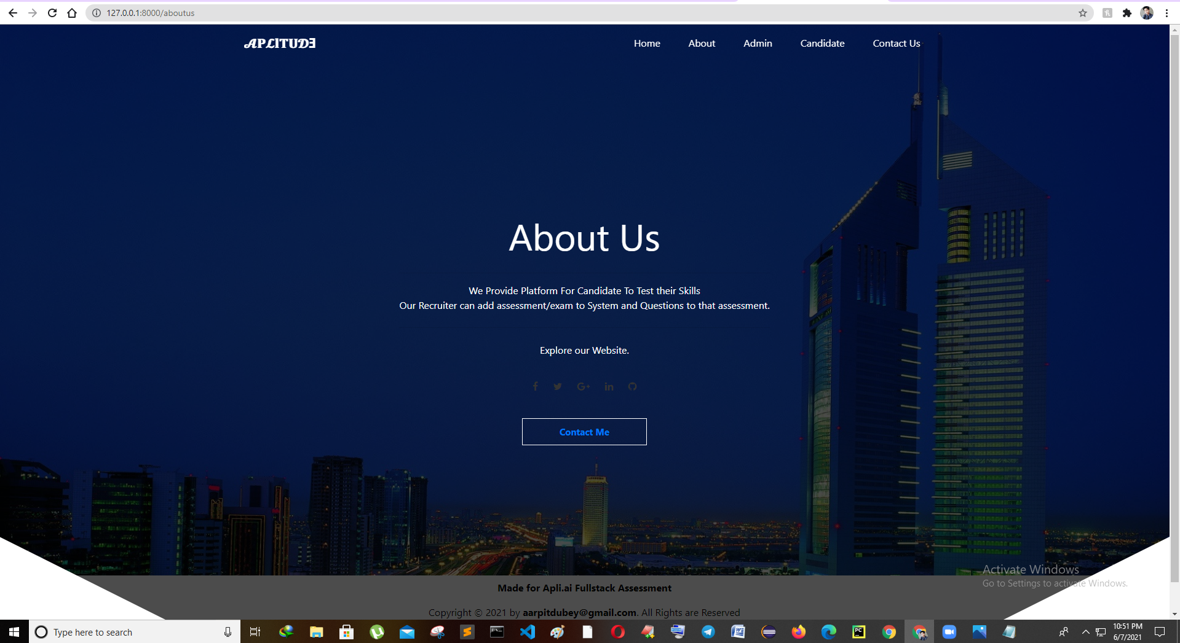

# Admin Page ( For Signing in )

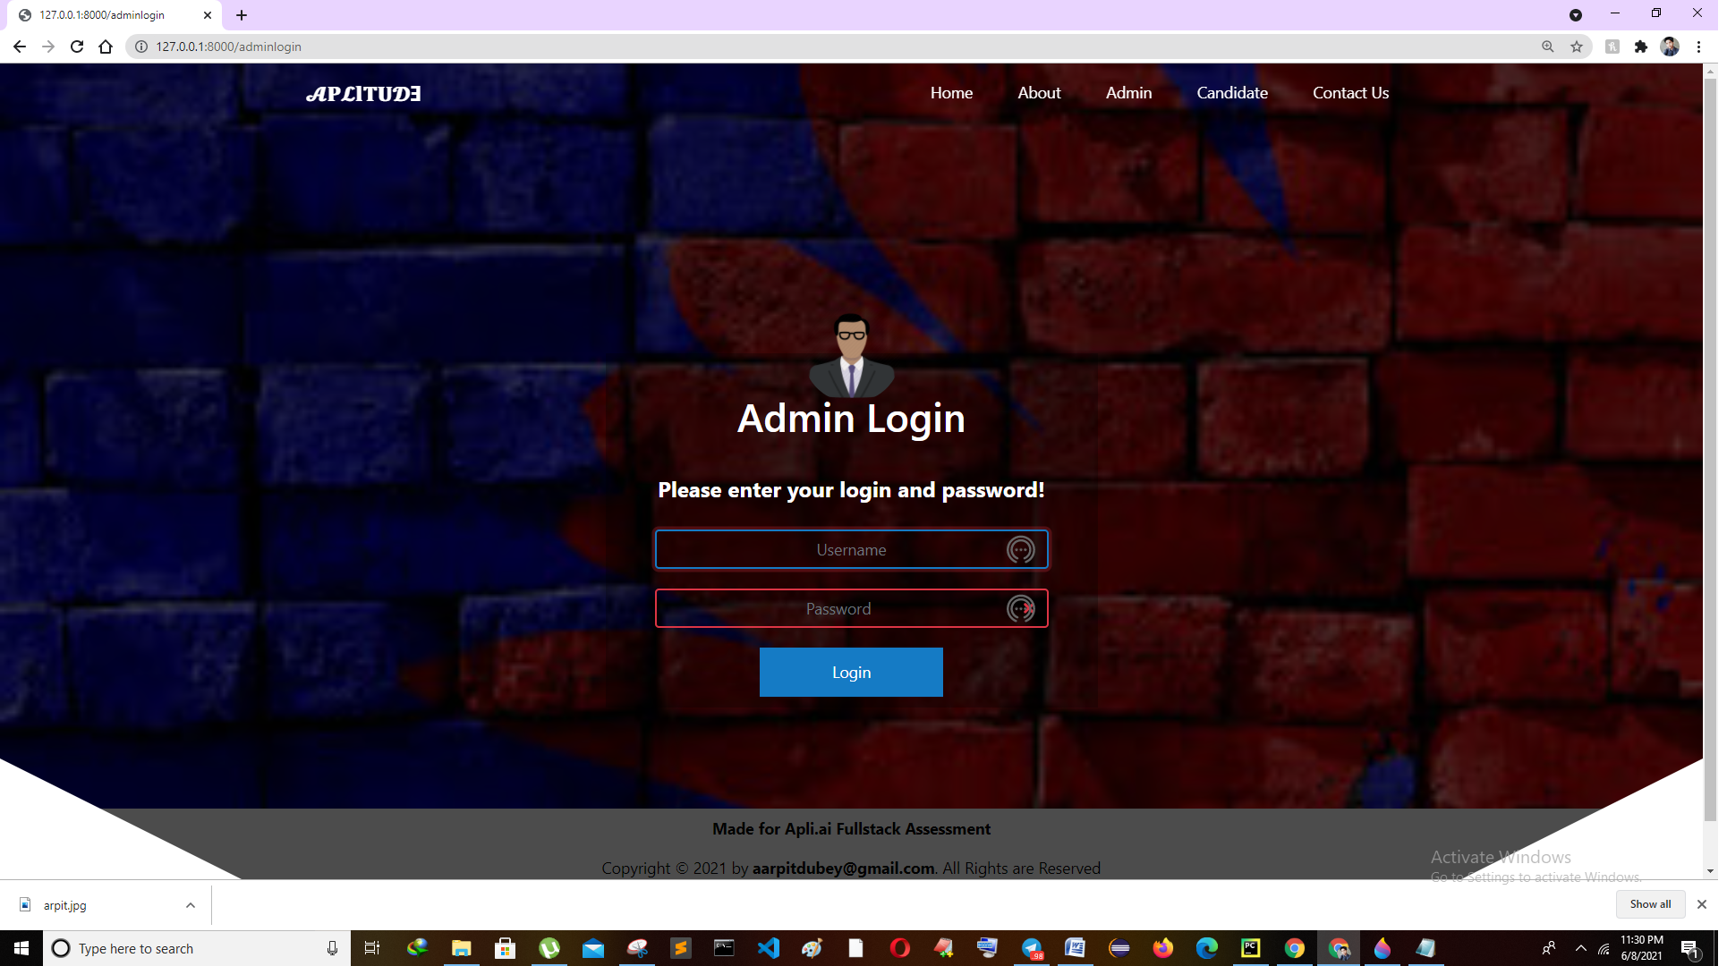

# Candidate Page (Can Sign In or Sign Up)

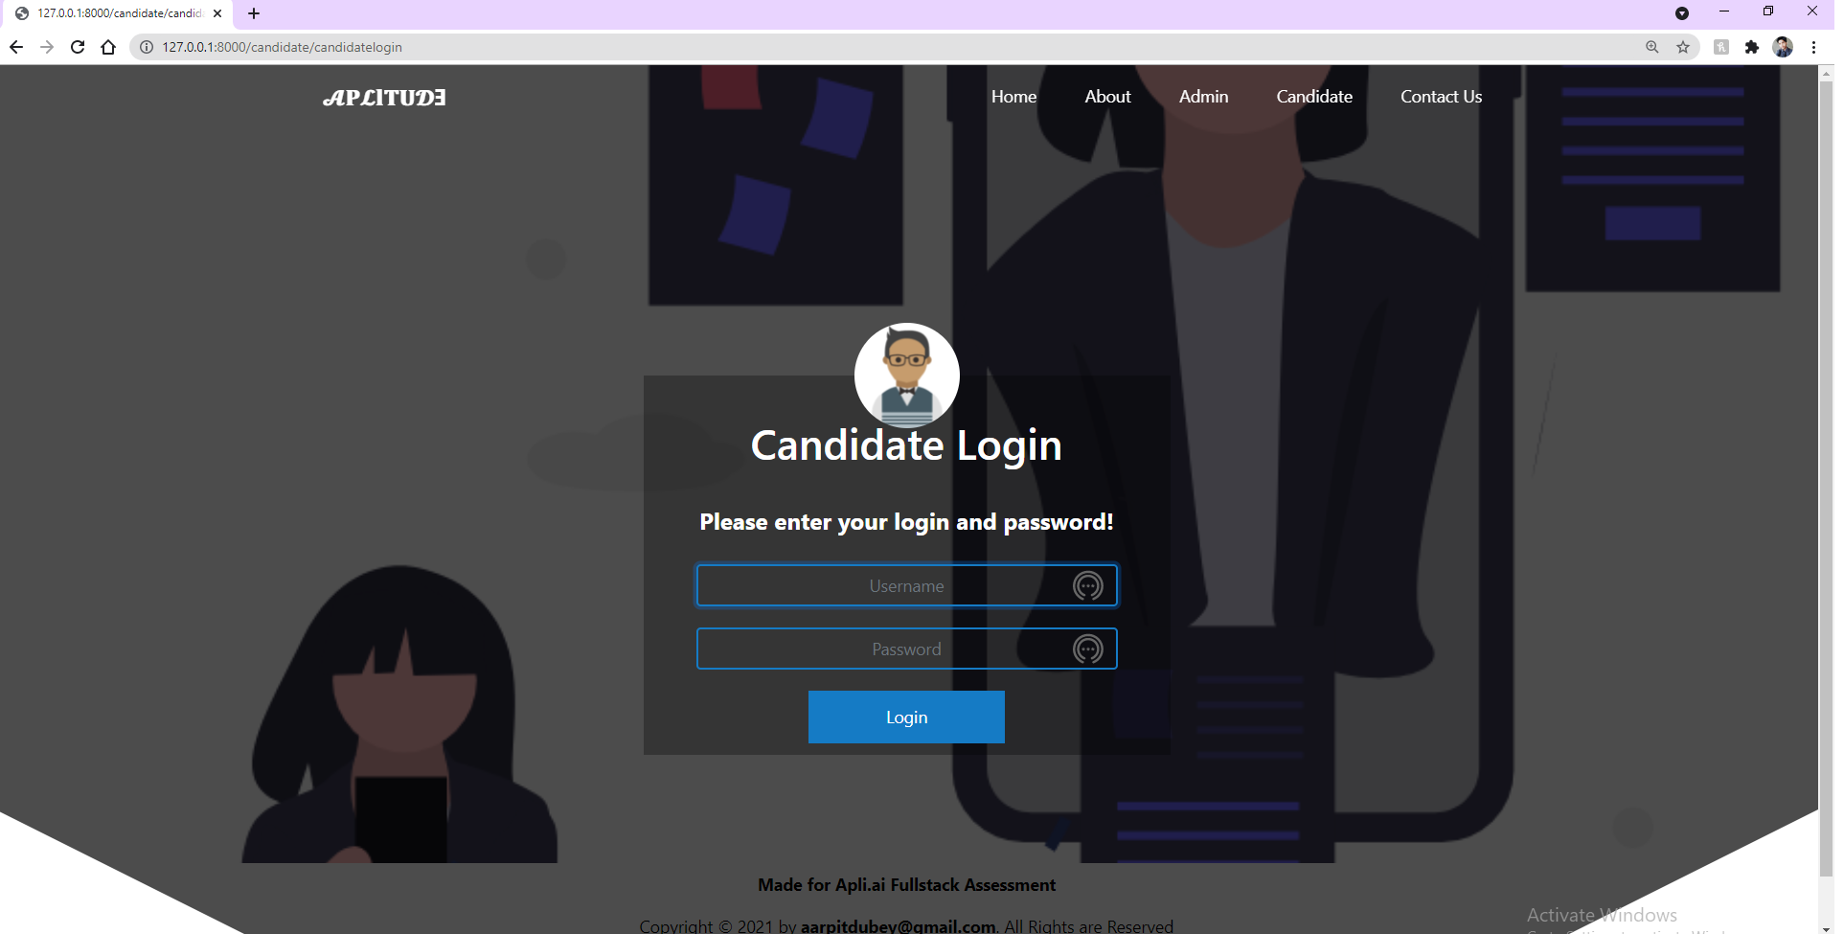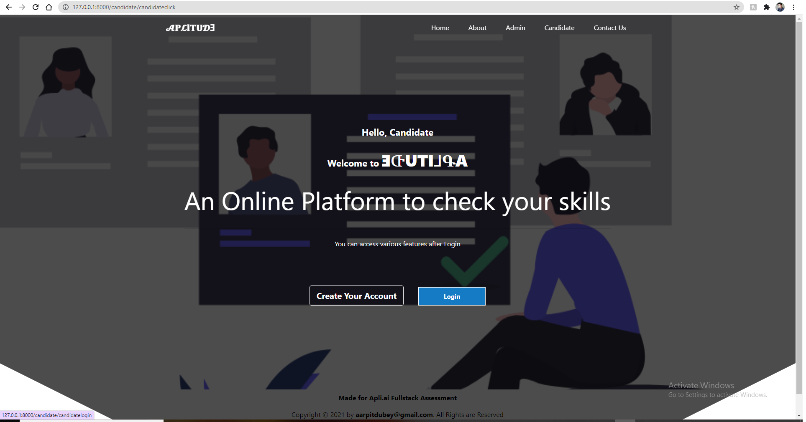

# Contact Page

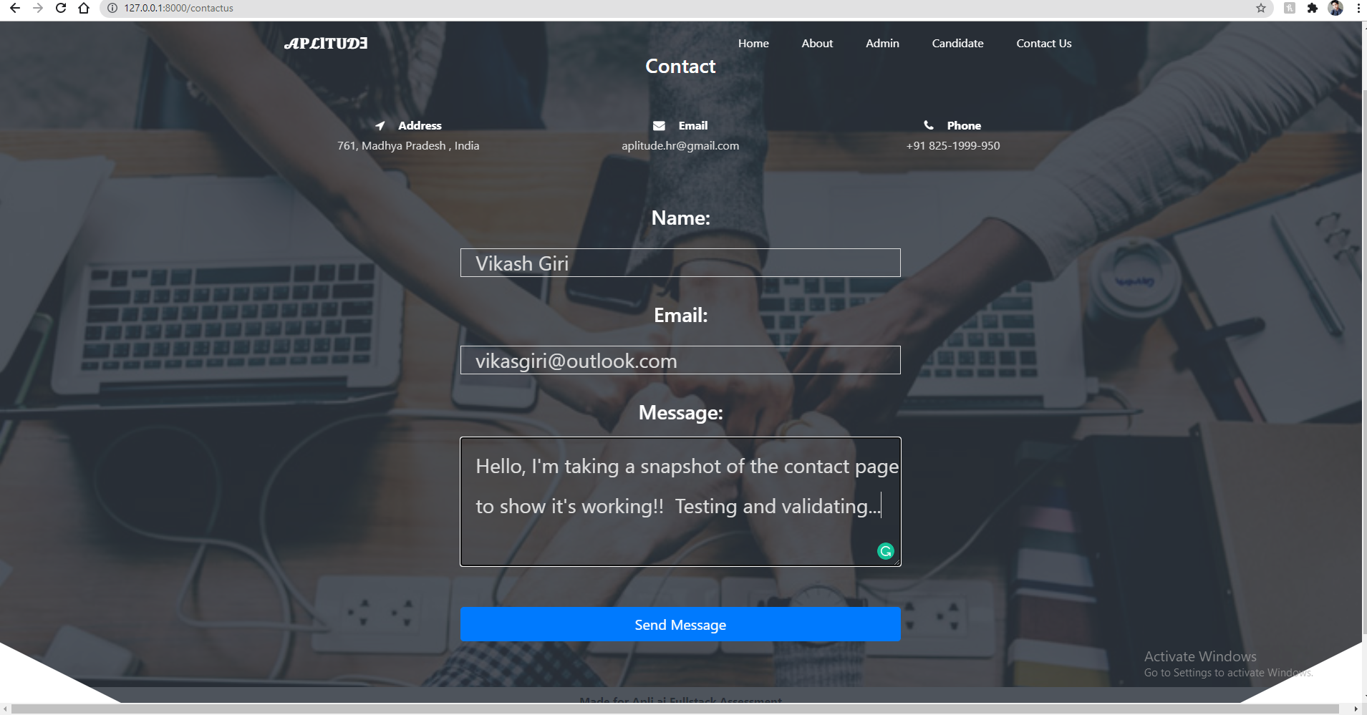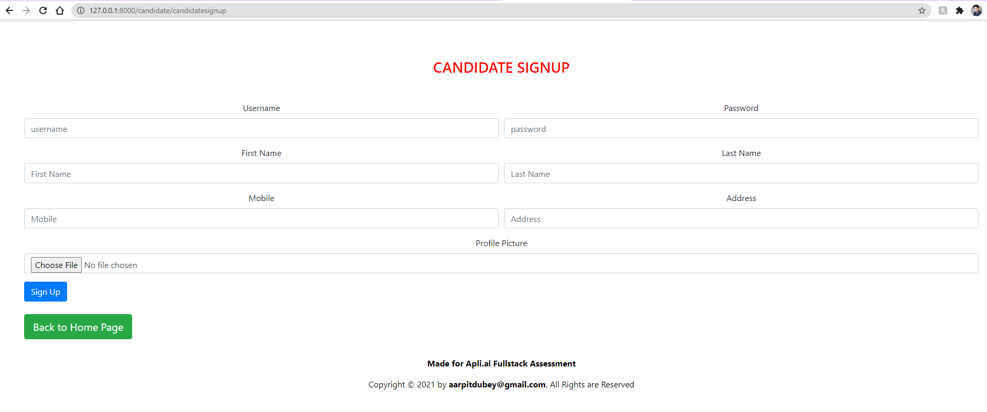

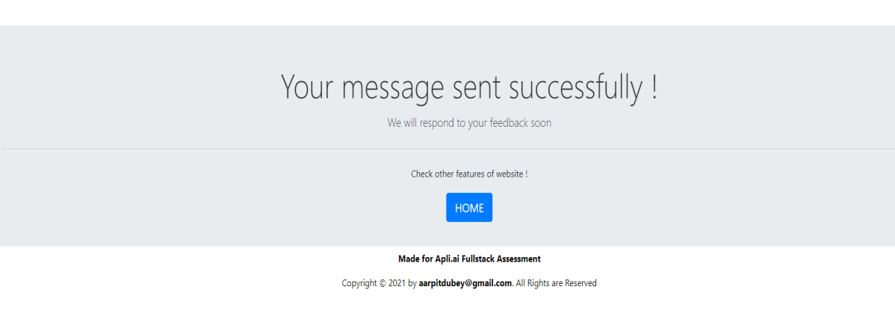

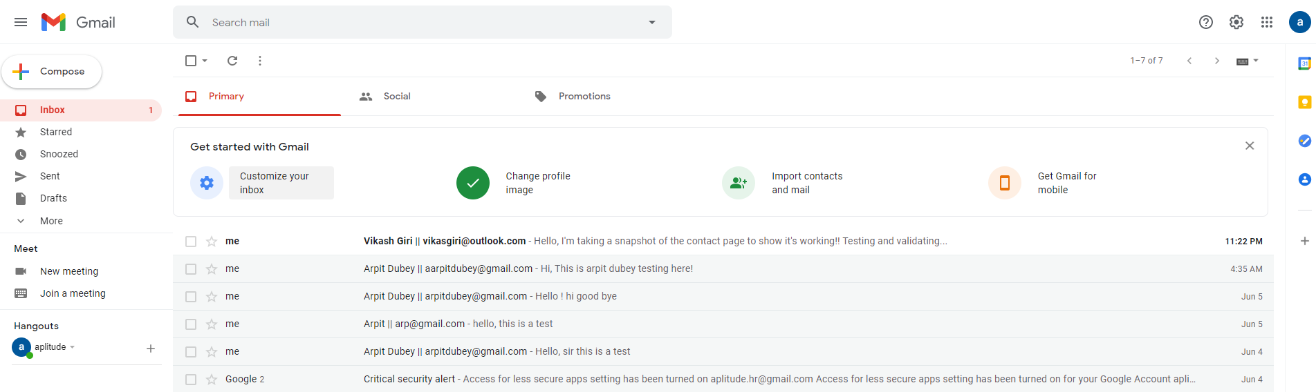

Now, Checking the dummy email id for the result does this message sent to that email id or not and with username and his email id.

**Functions**

1. **Admin**

* Create Admin account using command

**py manage.py createsuperuser**

* After Login, can see Total Number Of Candidates, Assessment, Questions are there in system on Dashboard.
* Can View, Update, Delete, Candidate details.
* Can View, Update, Delete Assessments.
* Can Also See Candidate Marks.
* Can Add, View, Delete Exams.
* Can Add Questions To Respective Assessments With Options, Correct Answer, And Marks.
* Multiple attempts for same assessment can be given by user for better progress.
* Can View And Delete Questions Too.

1. **Candidates**

* Create account existing users can Login and new users have to Signup.
* After Login, can see Total Number Of Marks, Assessments, Questions, Attempts are there in system on Dashboard.
* Can Give Exam, multiple no. of times to improve their skills.
* Can Ask doubt to HRs though email which is provided in ContactUs form of web ap.
* Can Also views results obtain in multiple attempts.

**HOW TO RUN THIS PROJECT:**

1. Install Python(3.7.6) (Dont Forget to check Add to Path while installing Python otherwise you have to manually do the same task.)
2. Open Terminal and Execute Following Commands :

**python -m pip install -r requirements.txt**

1. - Download This Project Zip Folder and Extract it

Move to project folder in Terminal. Then run following Commands :

**py manage.py makemigrations**

**py manage.py migrate**

**py manage.py runserver**

1. Now enter following URL in Your Browser Installed On Your Pc

[**http://127.0.0.1:8000/**](http://127.0.0.1:8000/)

**CHANGES REQUIRED FOR CONTACT US PAGE**

In **settins.py file**, you have to give your email and password

**EMAIL_HOST_USER = 'youremail@gmail.com'**

**EMAIL_HOST_PASSWORD = 'your email password'**

**EMAIL_RECEIVING_USER = 'youremail@gmail.com'**

Here, I used a dummy email id for getting emails from contact page of our web app!

#for contact us give your gmail id and password  
EMAIL_BACKEND ='django.core.mail.backends.smtp.EmailBackend'  
EMAIL_HOST = 'smtp.gmail.com'  
EMAIL_USE_TLS = *True*EMAIL_PORT = 587  
EMAIL_HOST_USER = 'aplitude.hr@gmail.com' # this email will be used to send emails  
EMAIL_HOST_PASSWORD = '@AplitudeHR1' # host email password required  
# now sign in with your host gmail account in your browser  
# open following link and turn it ON  
# https://myaccount.google.com/lesssecureapps  
# otherwise you will get SMTPAuthenticationError at /contactus  
# this process is required because google blocks apps authentication by default  
EMAIL_RECEIVING_USER = ['aplitude.hr@gmail.com'] # email on which you will receive messages sent from website

You can check out this dummy email address for the correction.

**Email id:** [**aplitude.hr@gmail.com**](mailto:aplitude.hr@gmail.com)

**Password: @AplitudeHR1**

**Working (Flow of process)**

**Admin Login:**

1. Once you logged in through **Admin Login Page** then you will be **directly redirected to Create assessment Page**.

## C:\Users\windows10\AppData\Local\Microsoft\Windows\INetCache\Content.Word\Dashboard.png<http://127.0.0.1:8000/create-assessment-page>

1. Here, you will get an  **Admin Panel,**  which has three following modules:
2. Dashboard
3. Candidates
4. Assessments
5. As, you login from **Admin login Page**  you will redirected to **Assessments** module where you have four task modules :
6. Add Assessment
7. Add Question
8. View Assessment
9. View Question

# Add Assessment Page:

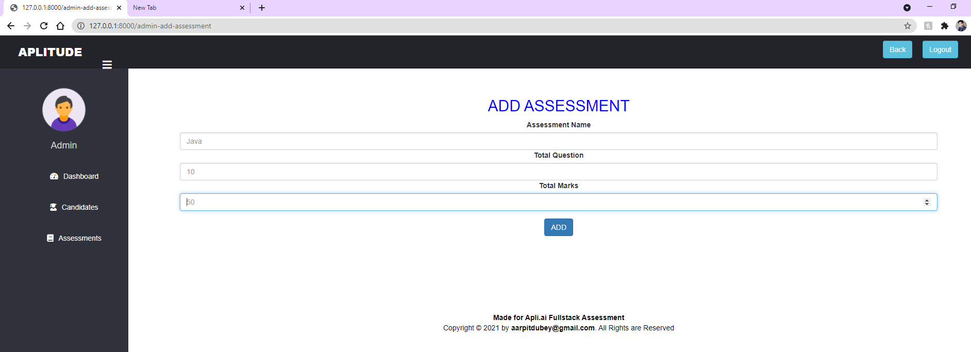

# Add Question Page:

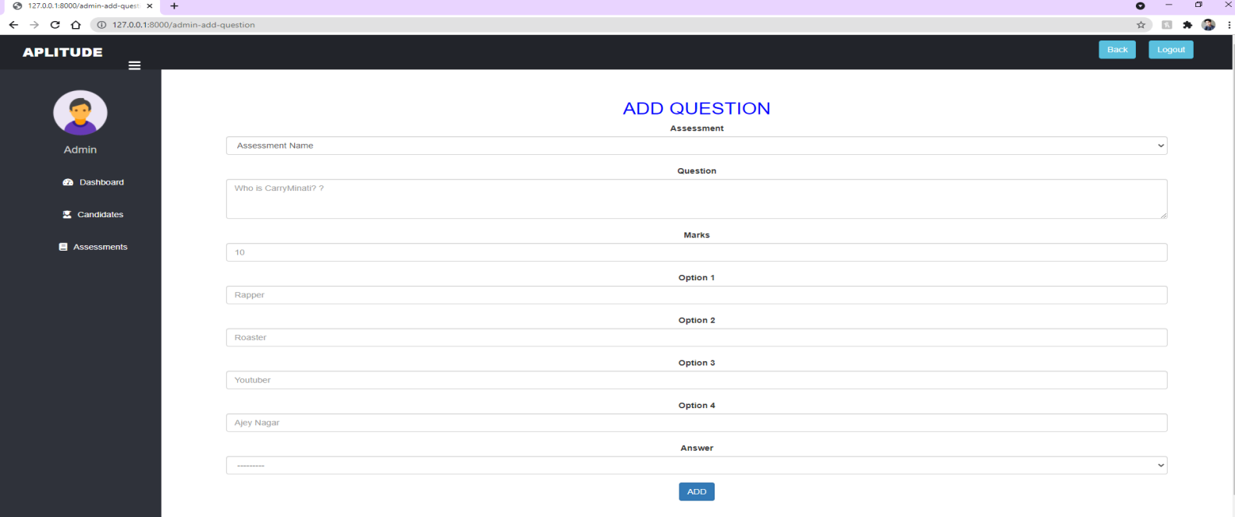

# View Assessment Page:

# 

# Deleting and Add new Question directly

# View Question Page:

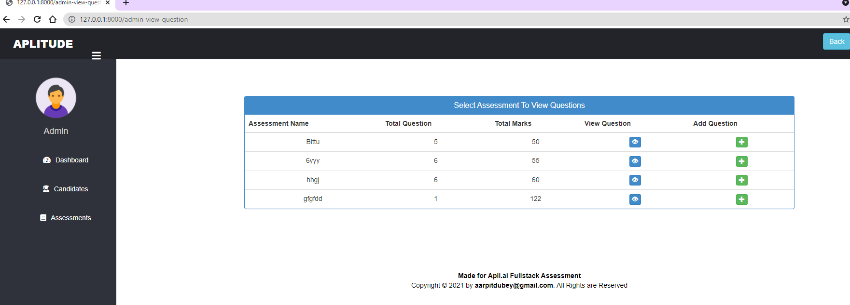

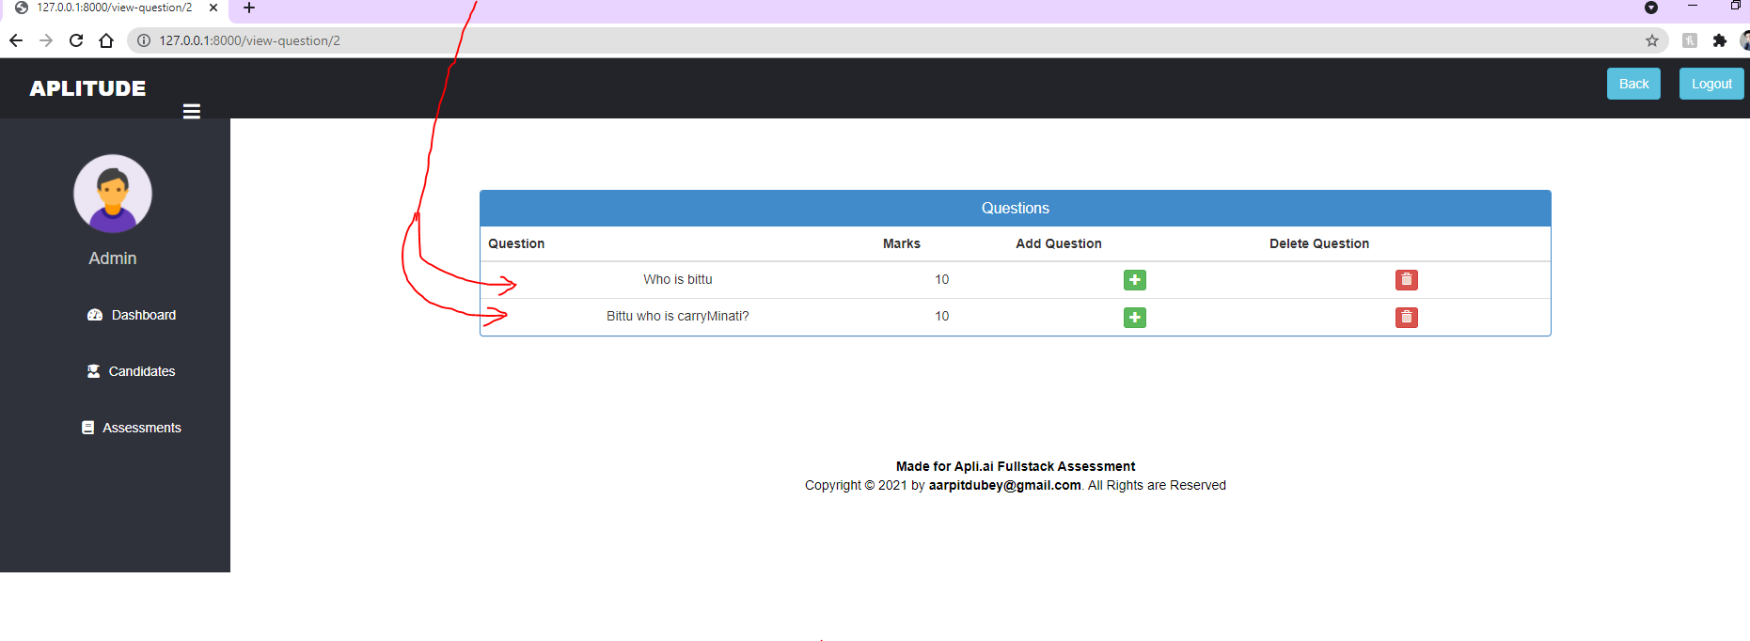

1. Admin **Dashboard Page,**  it has three task modules:

i). Total Candidate

ii). Total Assignment

iii.) Total Question

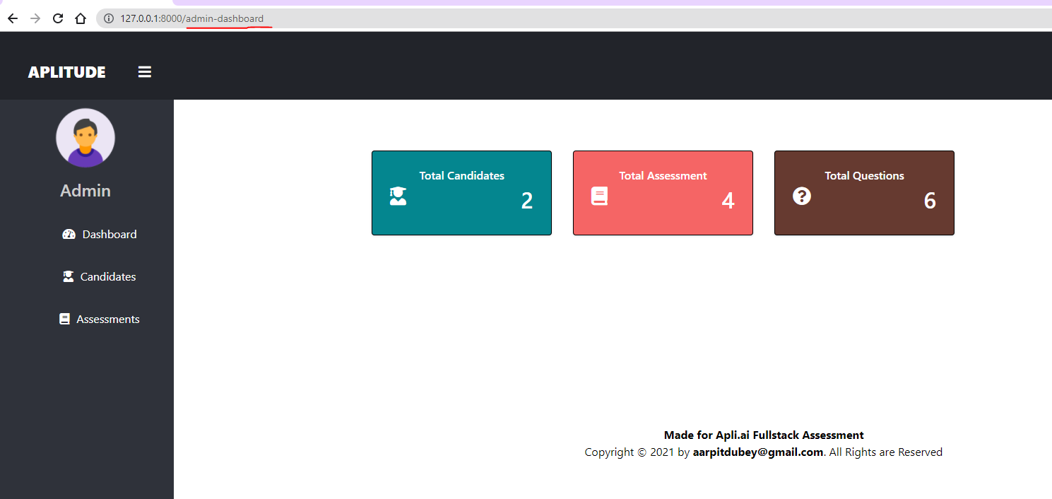

A). **Total Candidate:**  This module contains the detail of Candidates like, their name, profile picture, mobile number, Address,

* Admin can update the candidate details such as name, profile picture, mobile number, Address, account password etc., and can also delete the candidate profile.

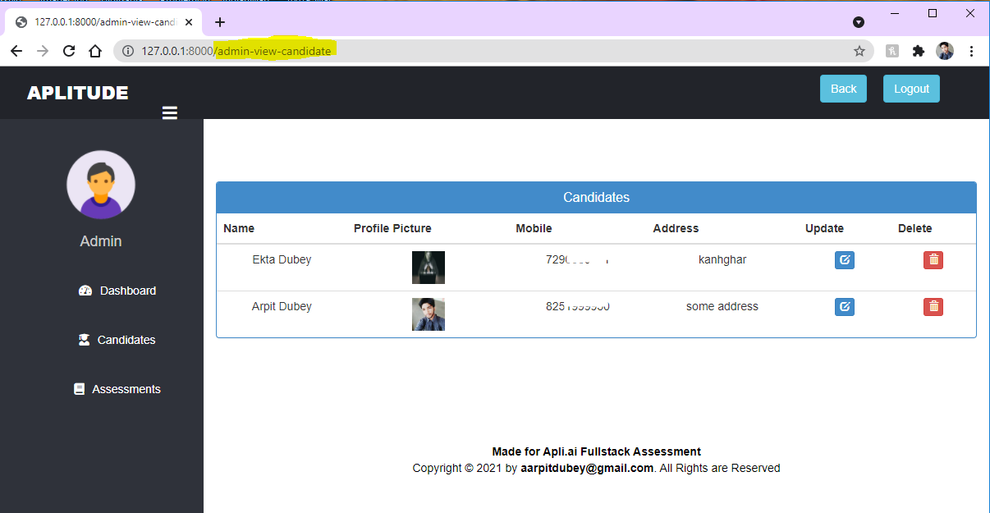

b).

B). **Total Assessment:**  This module have Assessment name (Java Assessment, Python Assessment etc.,), Total Question, Total marks allotted.

* Admin can **Delete** the assessment and from their only **add** more question to their Assessments

Example of Some dummy Assessments –

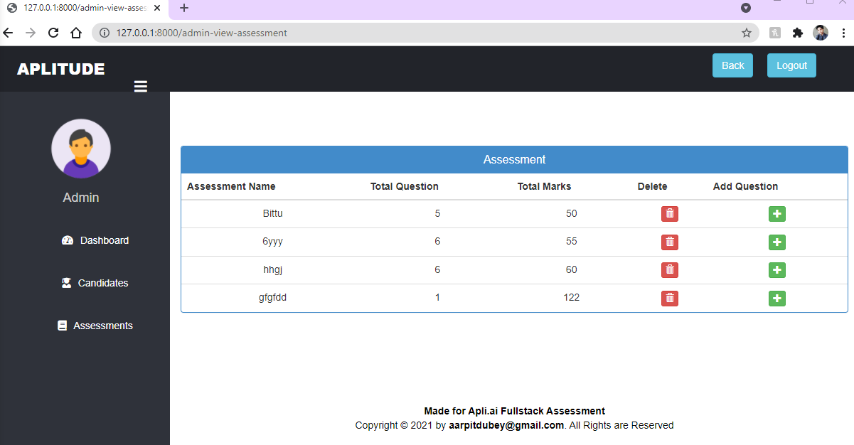

C). **Total Questions :** This module also contain Assessment name, Total Question you decide to put in a particular assessment, Total marks you want to set, Add Question directly from this module but the difference is now from here you can able to **View**  the Question you had given.

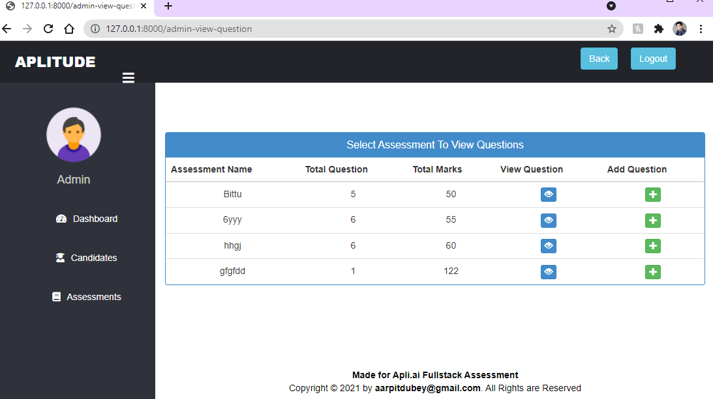

* Now, from the view page you can also **Delete or Add** Question.

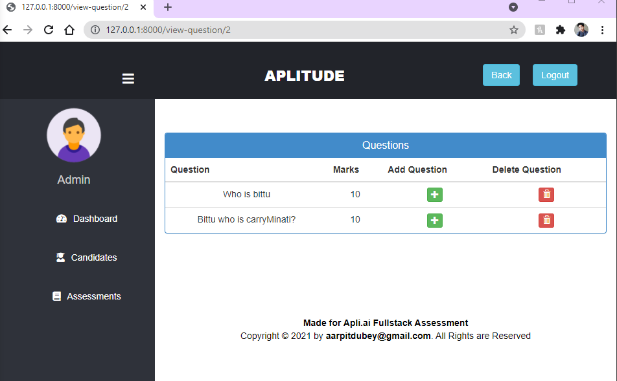

1. **Admin Candidates Page**

* **In Admin Panel,**  Candidates Module or Candidates Page redirect to **candidate detail page** that have two task modules :

1. **Total Candidate**
2. **Candidate Marks**

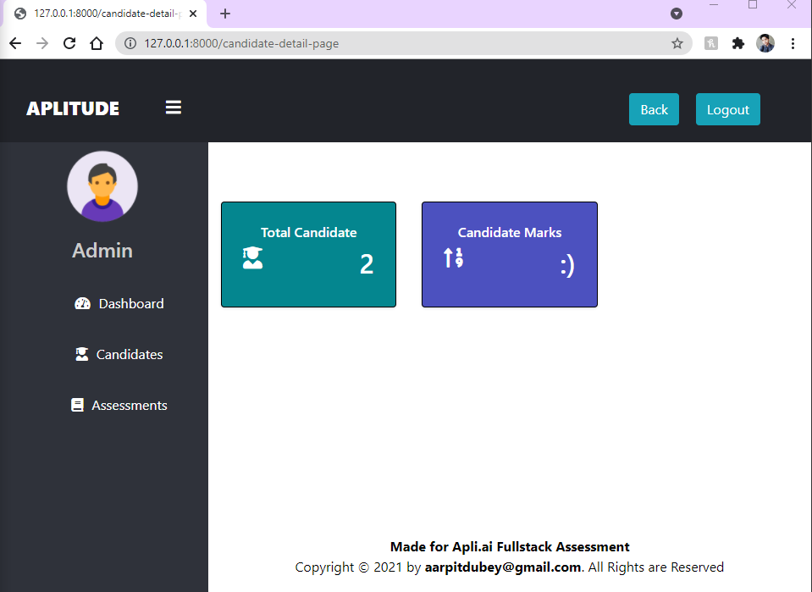

**Total Candidate:** This module contains the detail of Candidates like, their name, profile picture, mobile number, Address,

* Admin can update the candidate details such as name, profile picture, mobile number, Address, account password etc., and can also delete the candidate profile.

**Note:** You can also, see the same task module from **Admin** **Dashboard**

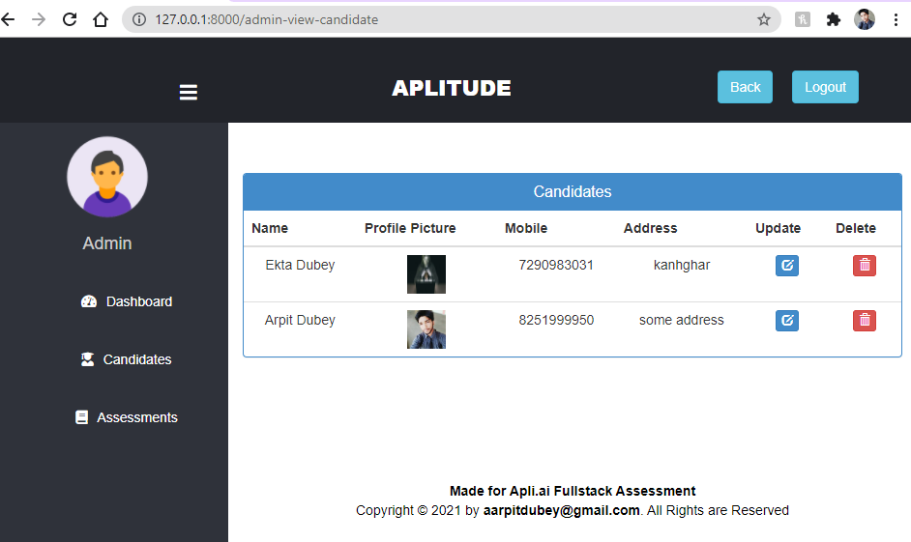

**Candidate Marks:** This module contains the marks of each Candidate who Signup and given the Assessment Test.

* Admin can view the marks of candidates for each Assessment Test or for Different Assessment Tests ( such as Java, Python etc.,)
* 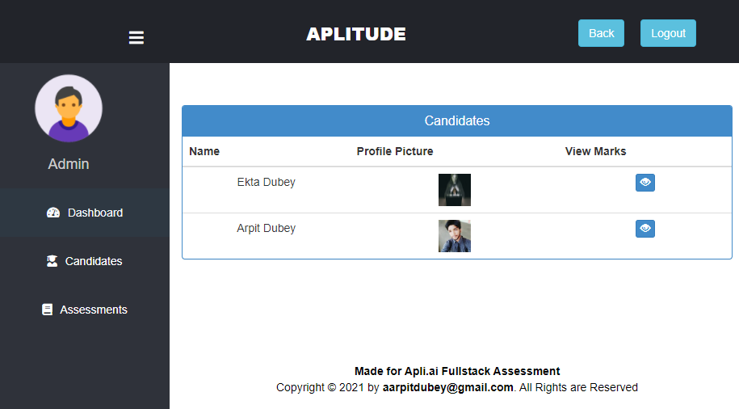on click **view marks page** admin can see the **Exam name, Marks obtained, Number of Attempts, Date & time of Exam given by the candidate**

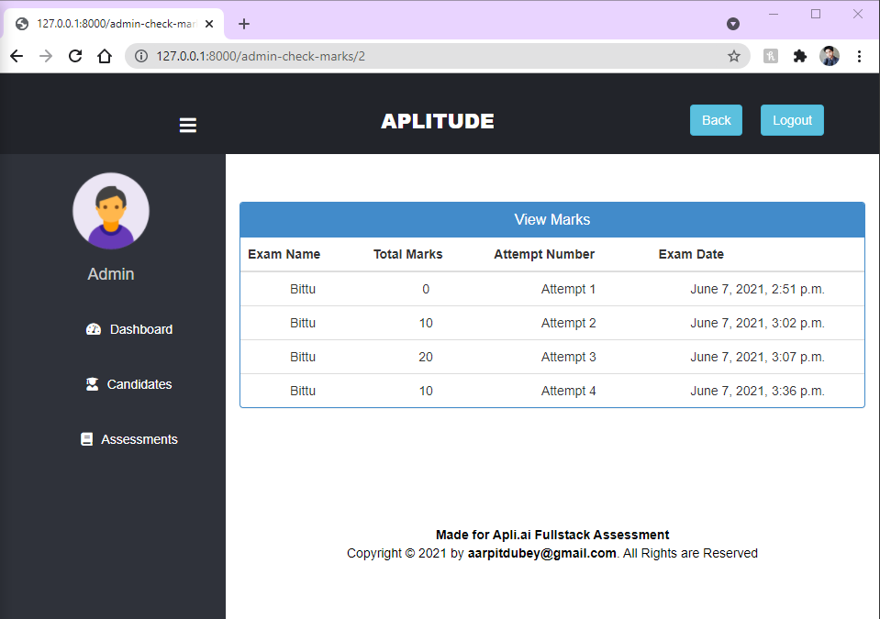

**Candidate Login:**

1. Once you logged in through **Candidate Login Page** then you will be **directly redirected to Candidate dashboard Page**.

## <http://127.0.0.1:8000/candidate/candidate-dashboard>

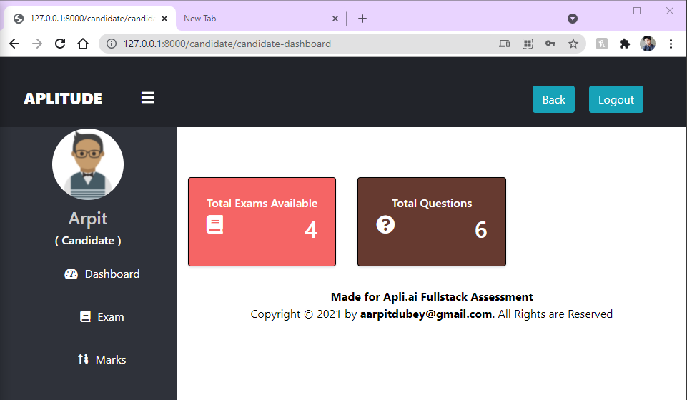

**Note: I’m working to set the candidate profile picture here in candidate profile dashboard.**

1. Here, you will get the **Candidate panel**  which have following modules:
2. Dashboard
3. Exam
4. Marks
5. **Dashboard:**  This module has two **Static** module:
6. **Total Exams Available:** Candidate can see total number of Assessment given to him and can also identify/get idea about the calculation of the assessment he/she/others had attended.
7. **Total Question:** Candidate get the idea about the number of total Questions he/she/others has to attend to finish all the assessment and get some idea if any of the assessment will be **updated with new Questions or any Question has been Added or Deleted.**



1. **Exam:** This module is useful for Candidate for taking the Exam or to start the test.

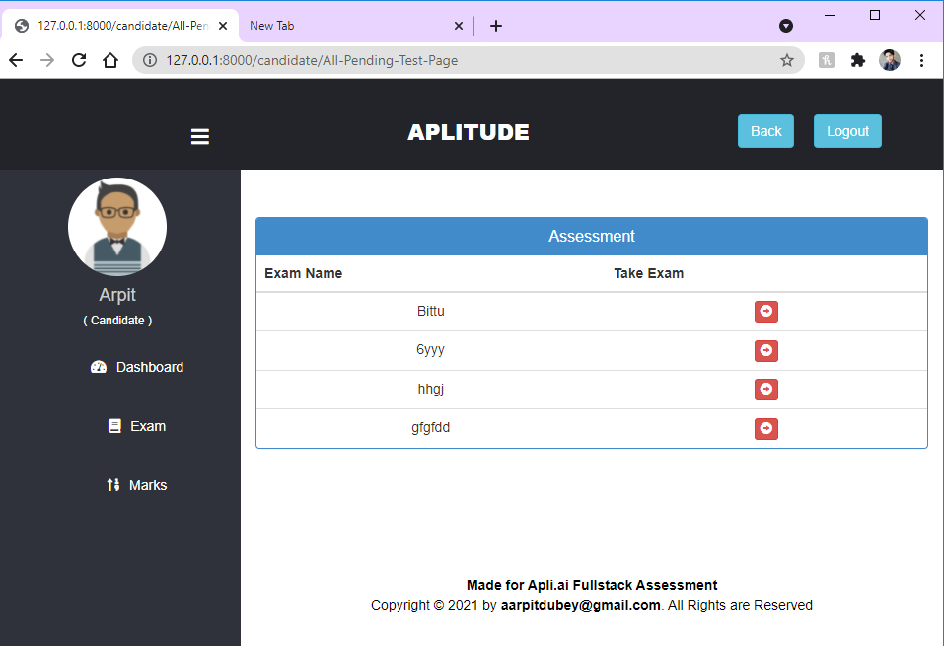

* 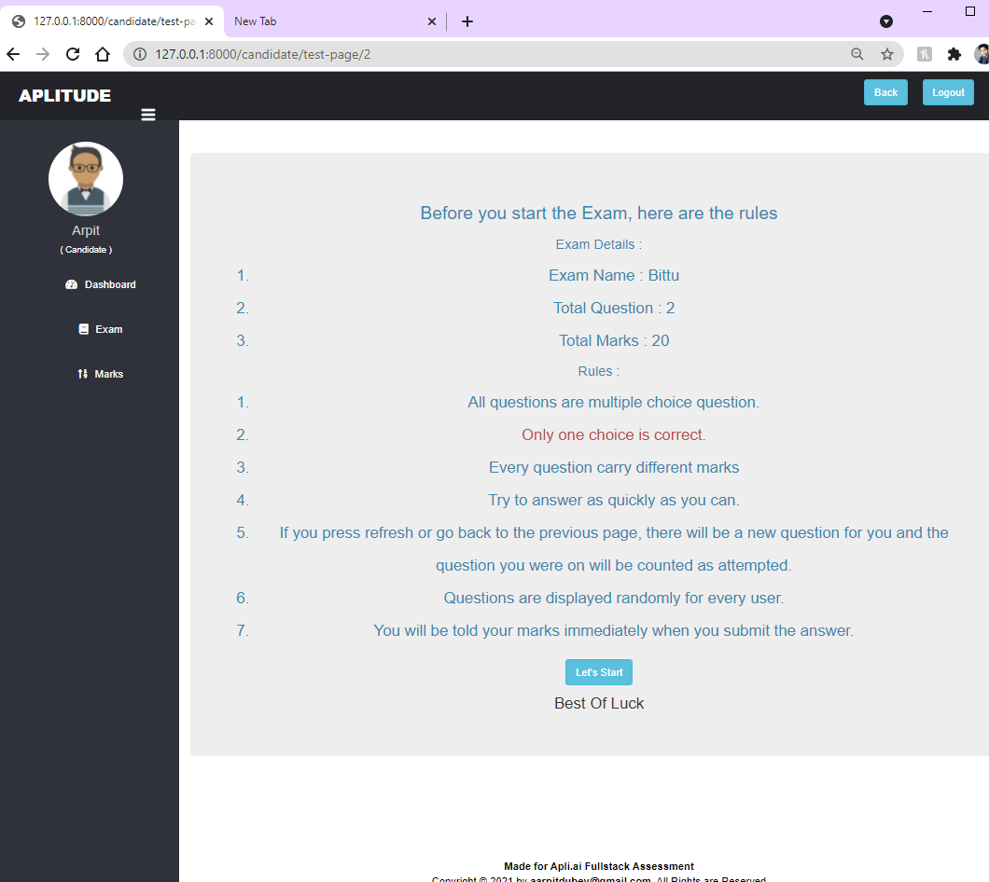After clicking on the **Take Exam** button of any Assessment, the rules page will be open. Before give exam candidate should know certain rules how to give the exam.
* After clicking **Let’s start** button Candidate can able to give the Assessment and answer the Questions that Assessment have. See each question have certain marks which is shown in the right side of the question.

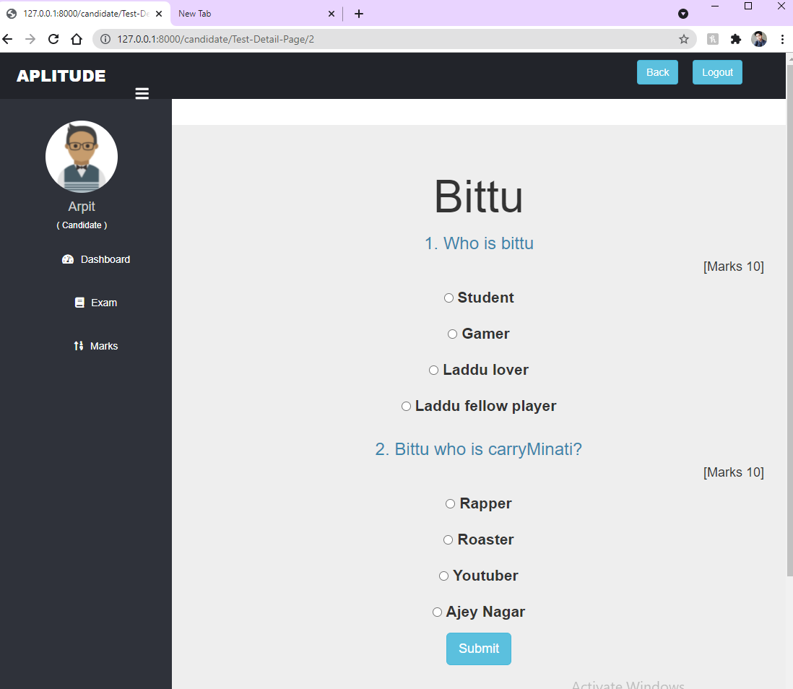

* 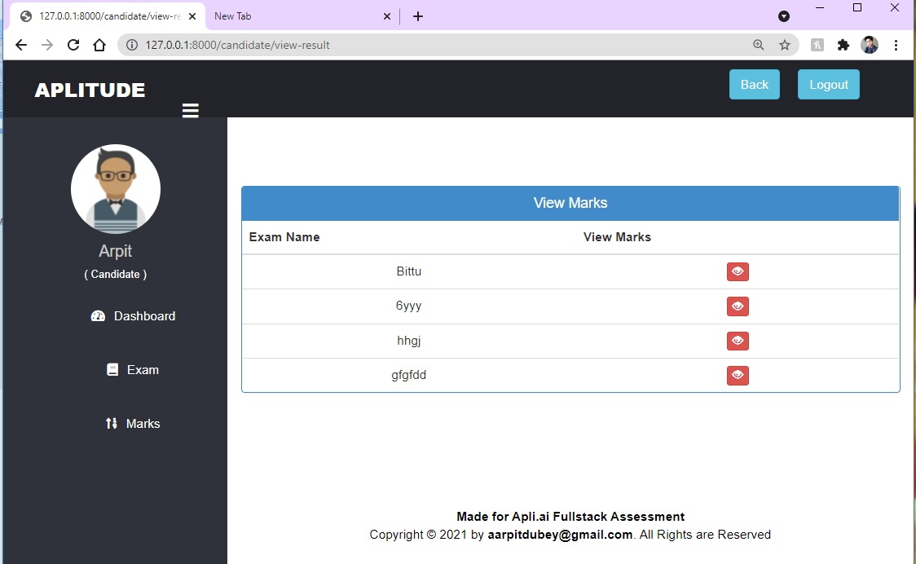After selecting the answers & clicking the **Submit** button candidate will be redirected to <http://127.0.0.1:8000/candidate/view-result> to see the Results of the Assessment.
* 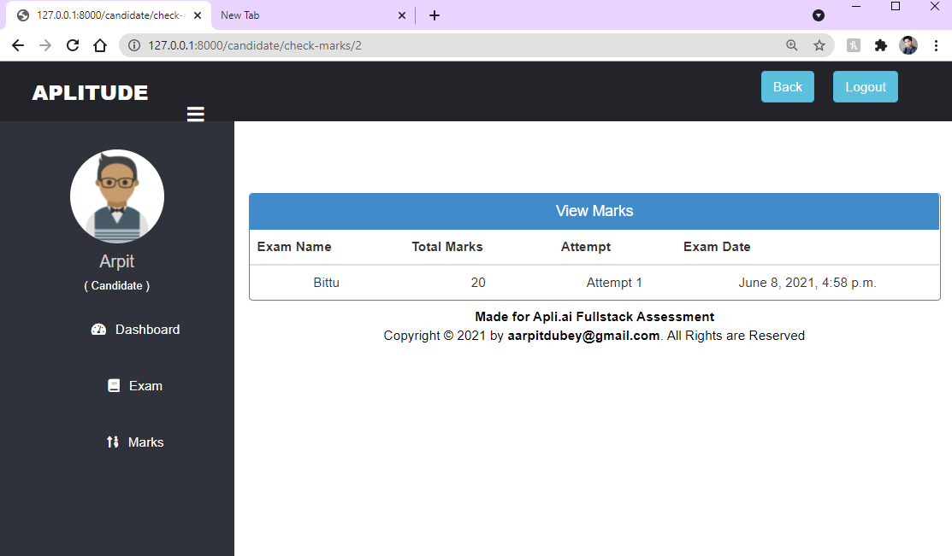Now, Candidate click the view button to see the results or marks obtained.

1. **Marks:** Here this module is use to see the results without giving one more attempt. Candidate can also directly see their marks to improve their performance.

* **The main reason is that candidate should know their previous performance result so they can able to improve.**

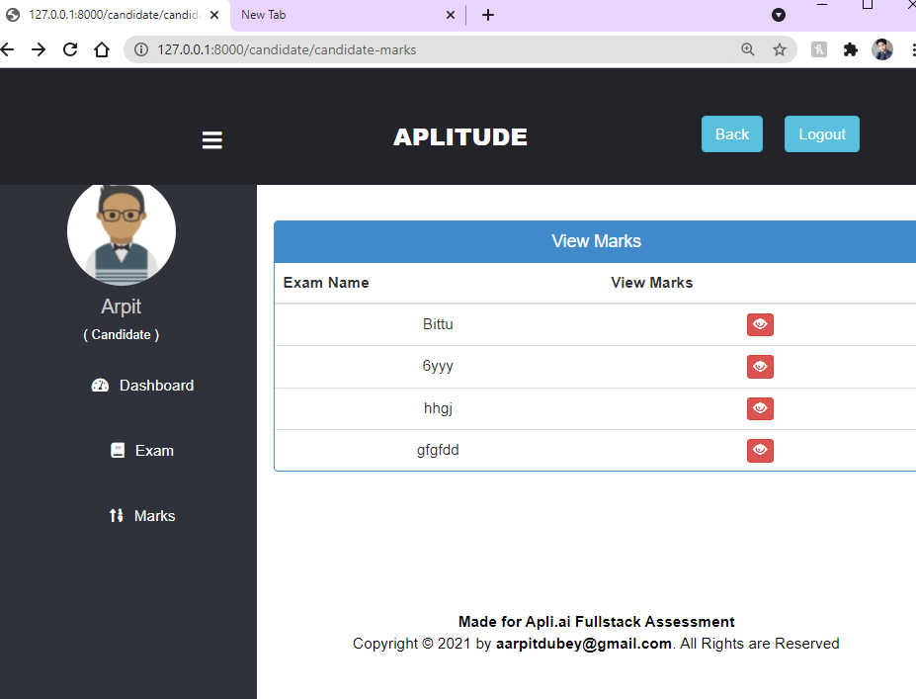

**Back Button:**  It is provided to move in previous page.

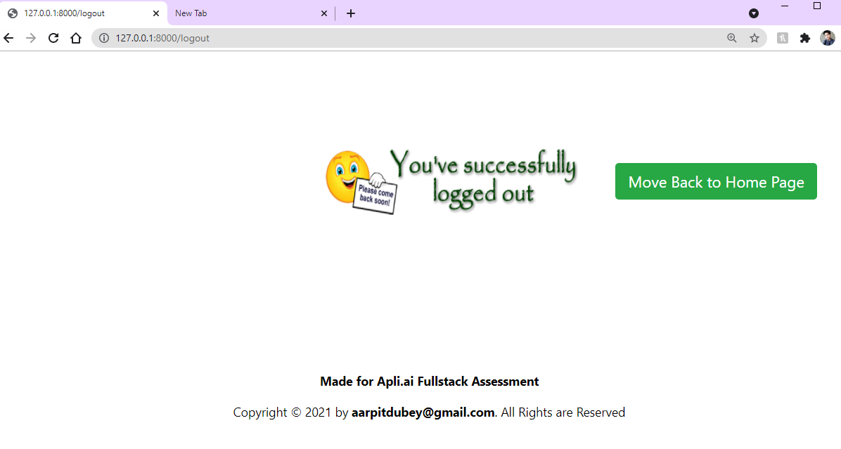**Log out Button:**  It is used to kill/terminate the login session. This button redirect the user to <http://127.0.0.1:8000/logout> which shows the successful message of logged out.

* **Log out Page:** It shows the successful message of being logged out and also a button **Move Back to Home Page** is there to re-login.
* 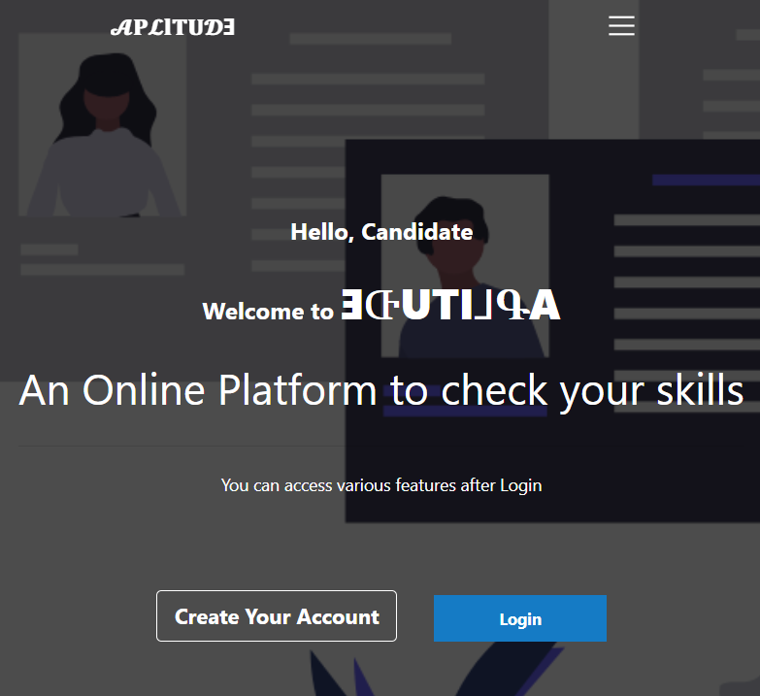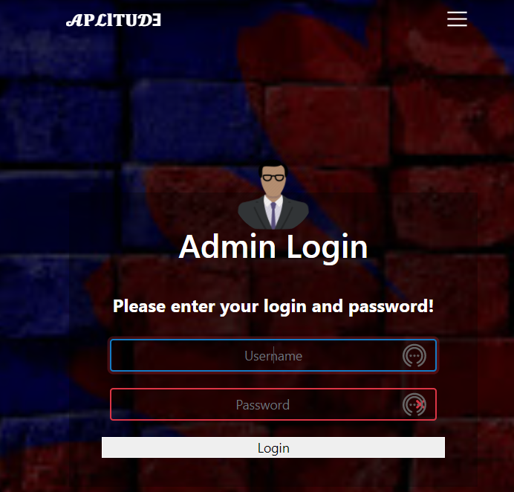Responsive web App with **Toggler Button.**

### ERROR: such as Candidate_Candidate Table not found

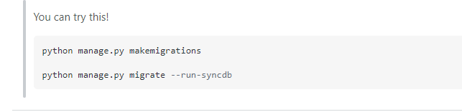

### Use Stackoverflow for errors due system change or migrations.

### THANK YOU FOR READING